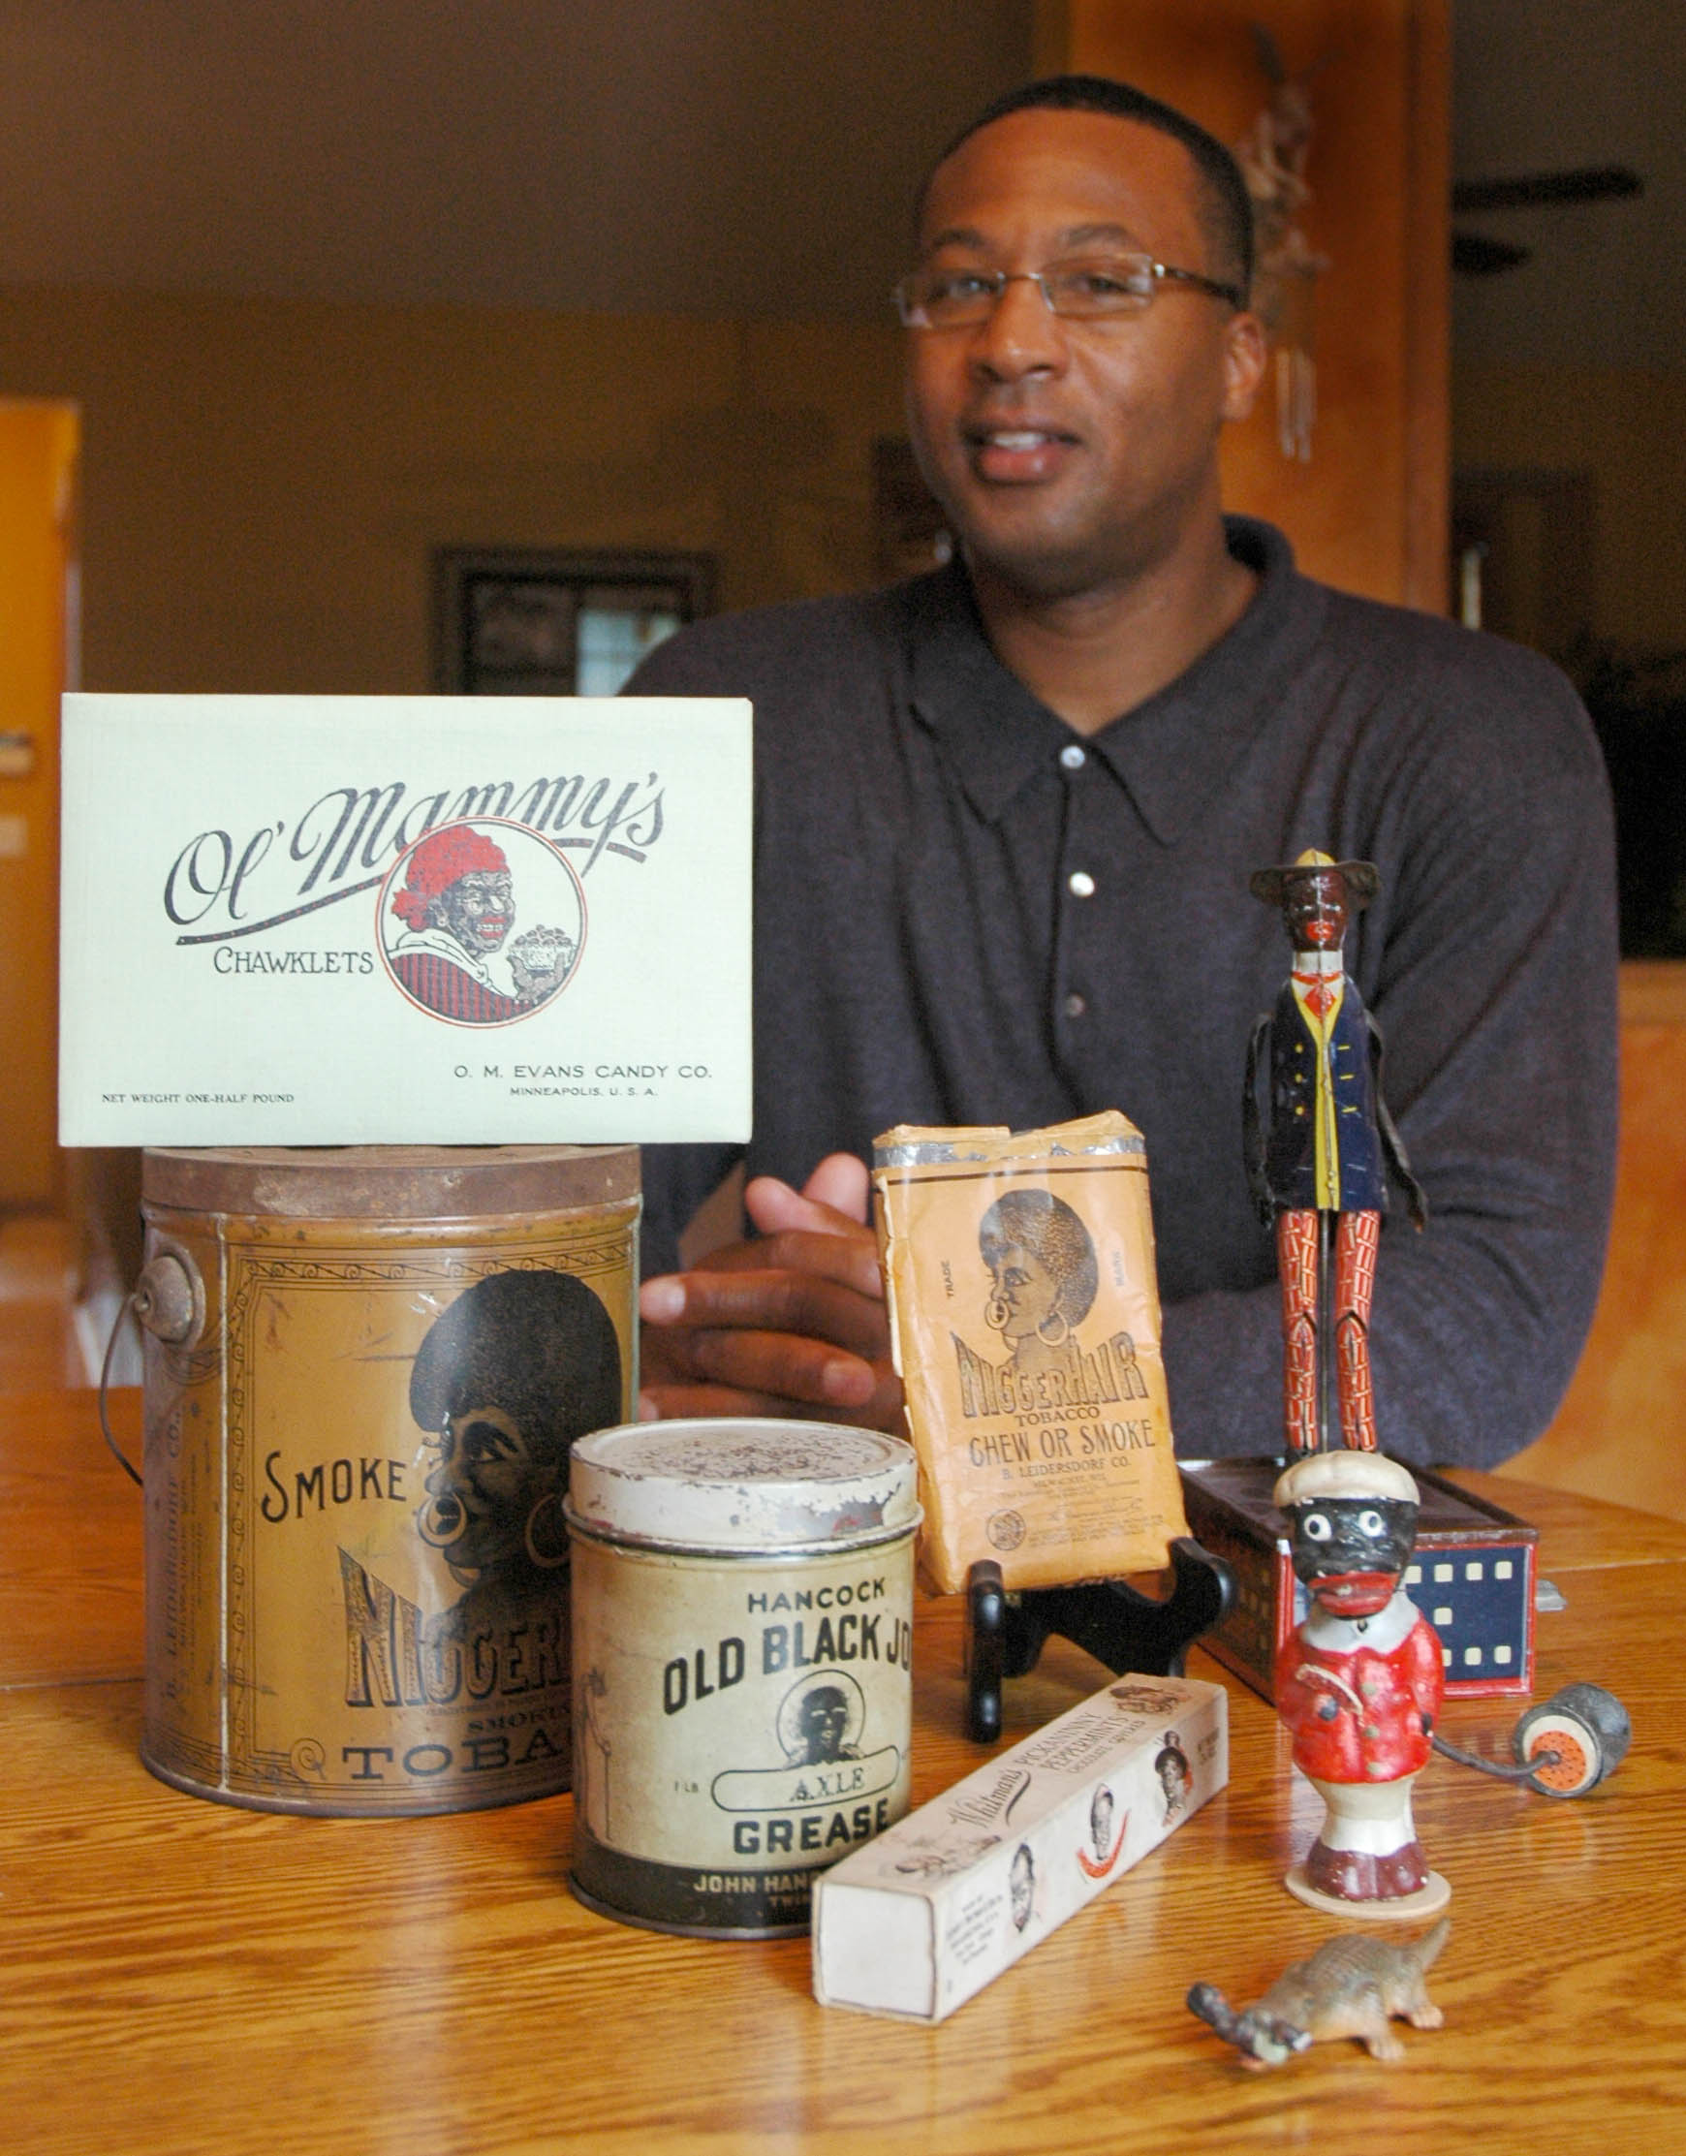

Client List

Tony and his programs inspire
and motivate like no one else can.

Tony Carr
Diversity Speaker

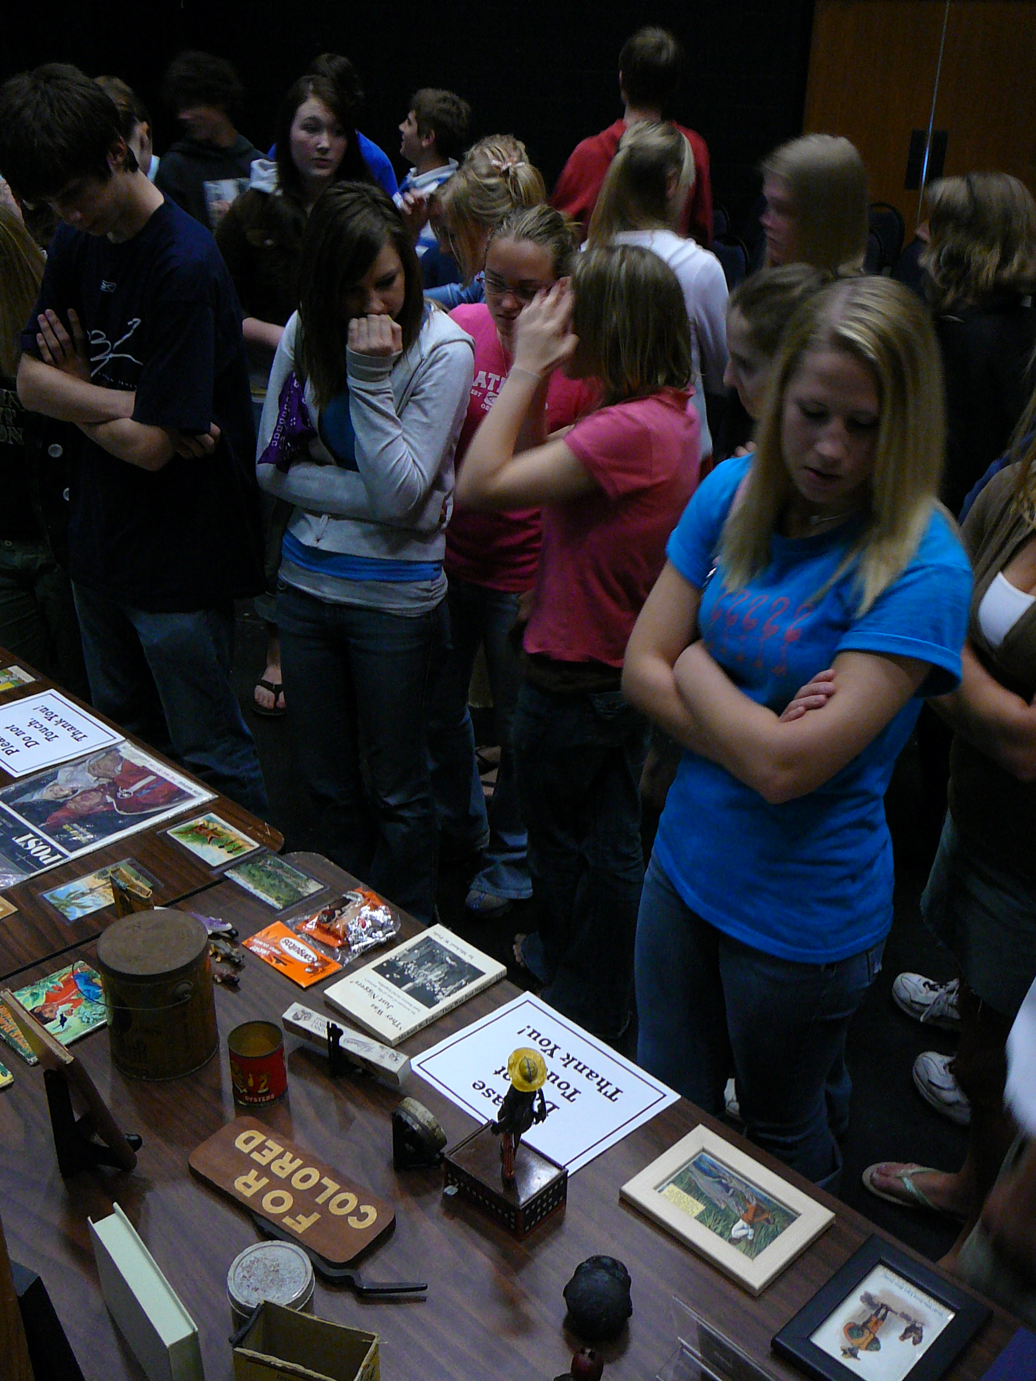
Educational Institutions
University of Wisconsin, Superior
Dakota County Technical College
Bethel College
Stillwater High School
Mahtomedi High School
Johnson High School
Roseville High School

Government
Washington County, MN

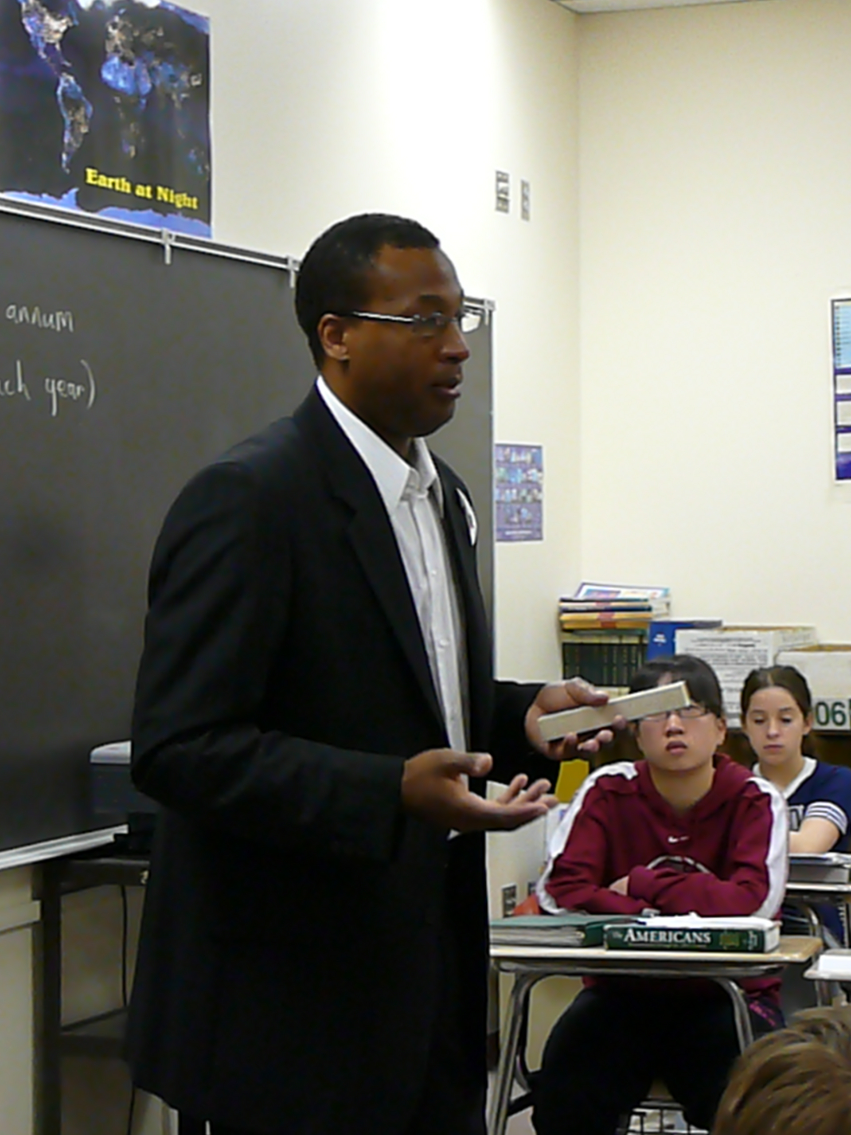
Businesses
Merrick, Inc

Churches
St. Paul Lutheran Church

Media Appearances
KARE11-TV Extra
Stillwater Gazette
St. Croix Valley Press

To book Tony Carr now visit
www.TonyCarr.org

