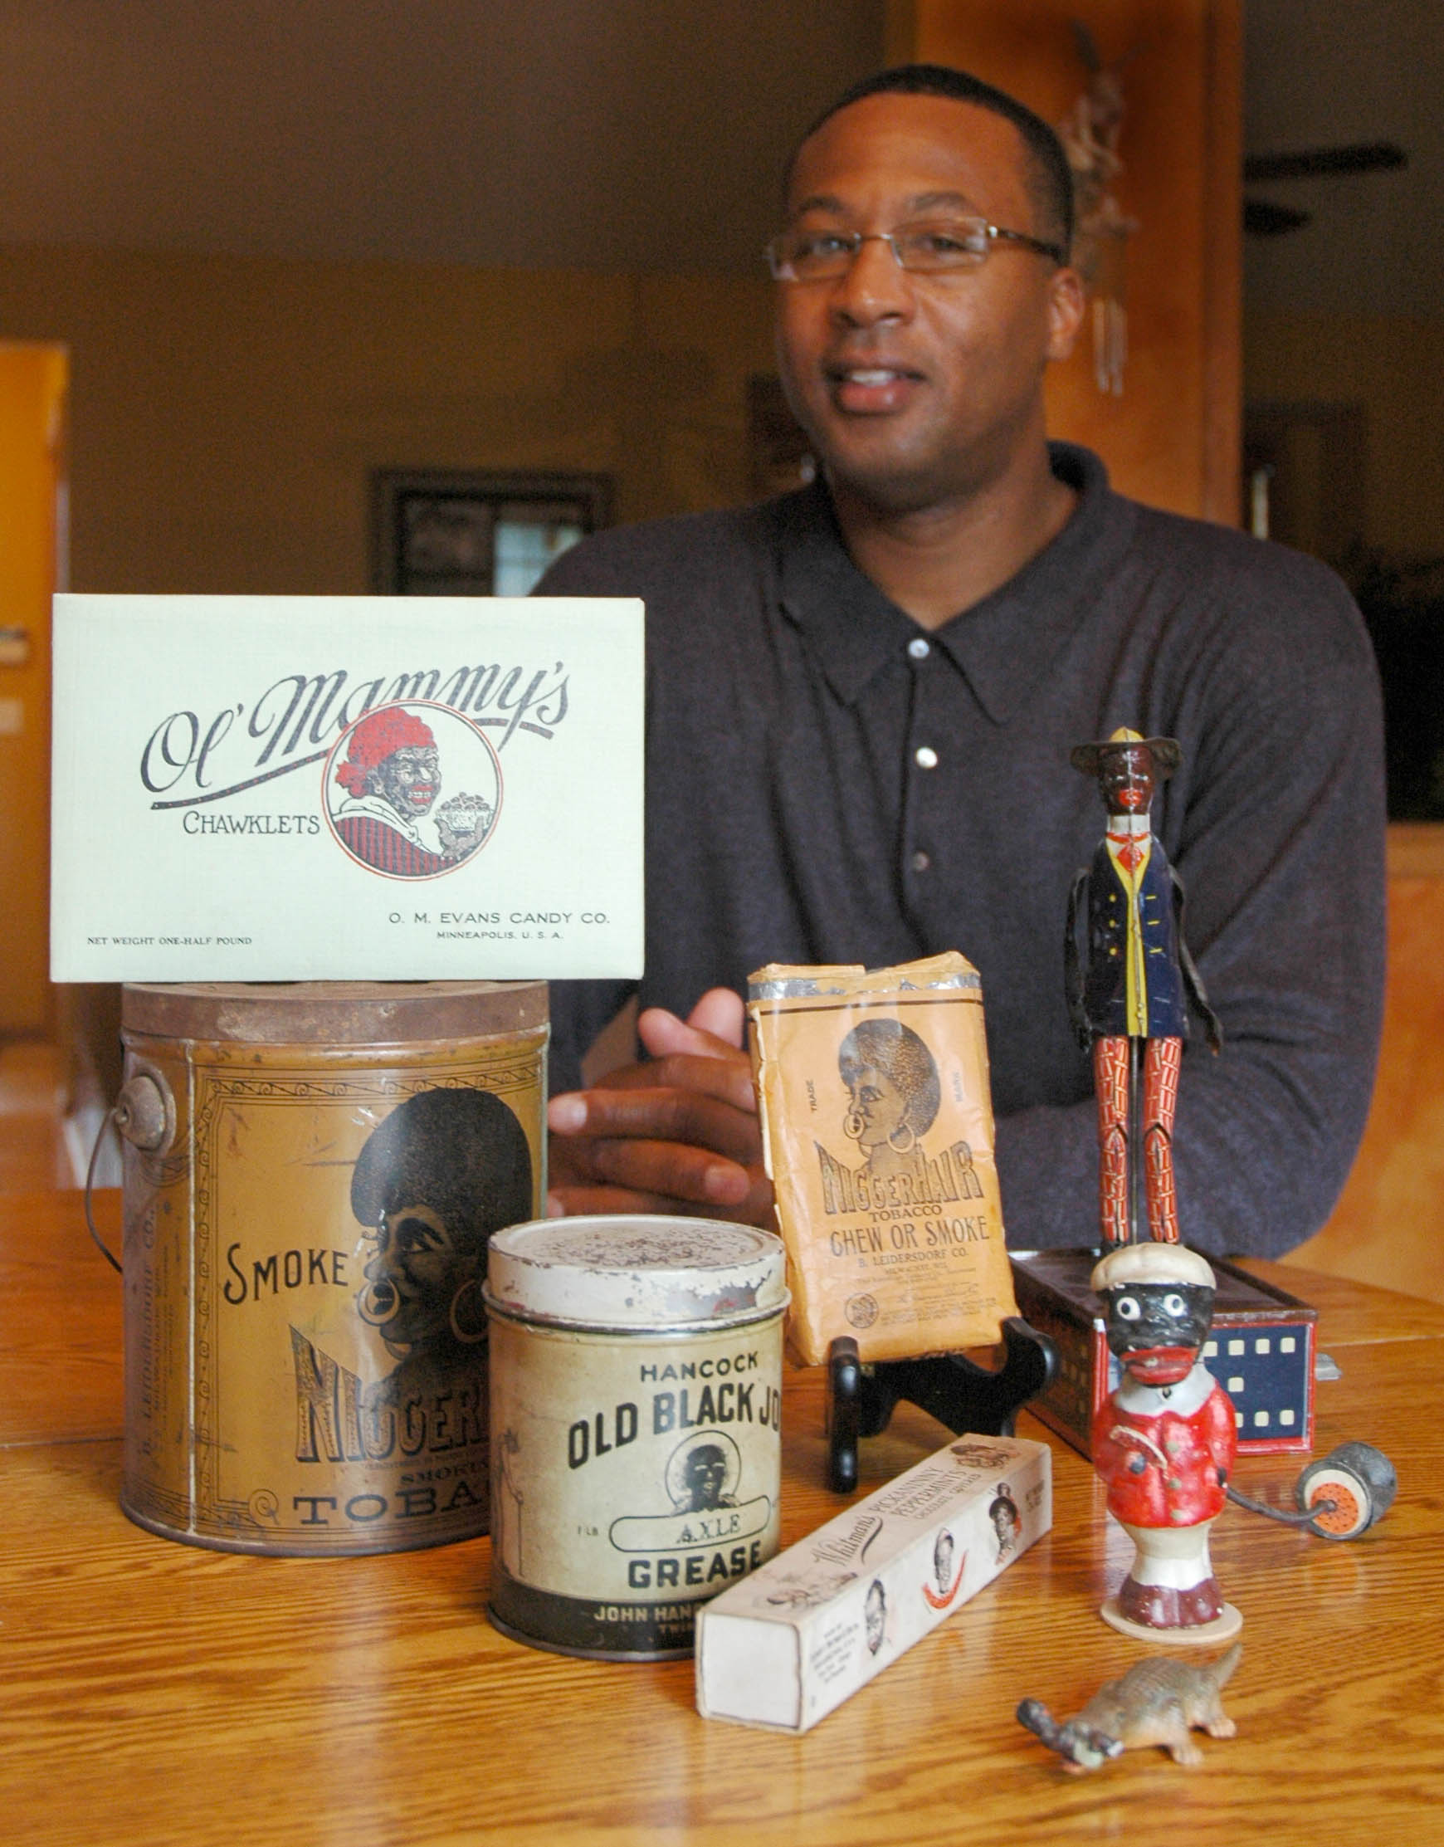

Presentation Outline

Tony and his programs inspire
and motivate like no one else can.

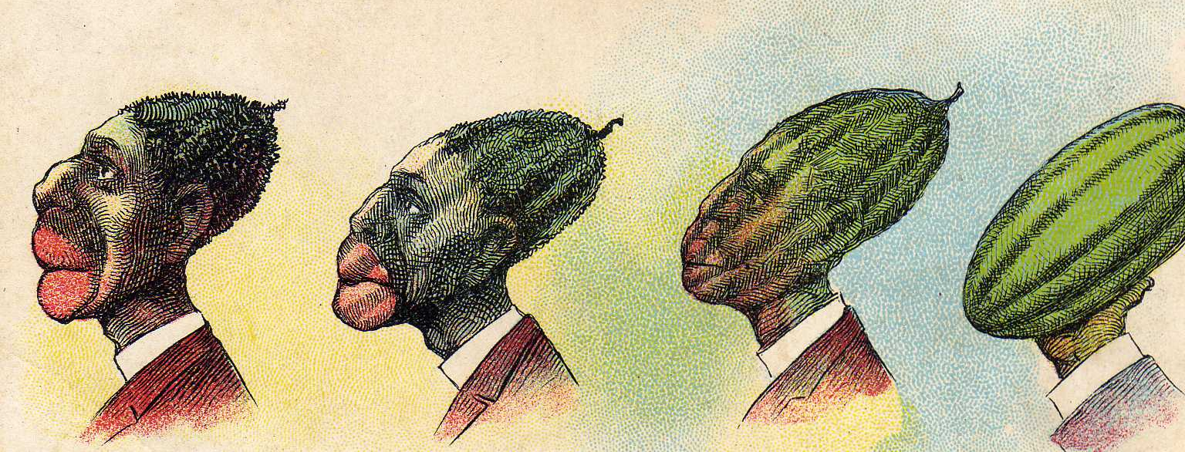
Tony Carr
Diversity Speaker

Description:
They are items that turn your stomach and open your eyes at the same time: a "Colored Waiting Room" sign, a package of "Pickaninny Peppermints", a "Nigger Head Stove Polish" tin, and a figurine depicting a black baby being used as alligator bait. It’s a display so vile you may want to turn away. But Black Memorabilia collector, Tony Carr, prefers you take a good, hard look. Most of the 500+ pieces he's acquired are degrading, offensive and distasteful. But Tony says they're a reminder of what others had to endure to clear the path he now travels.

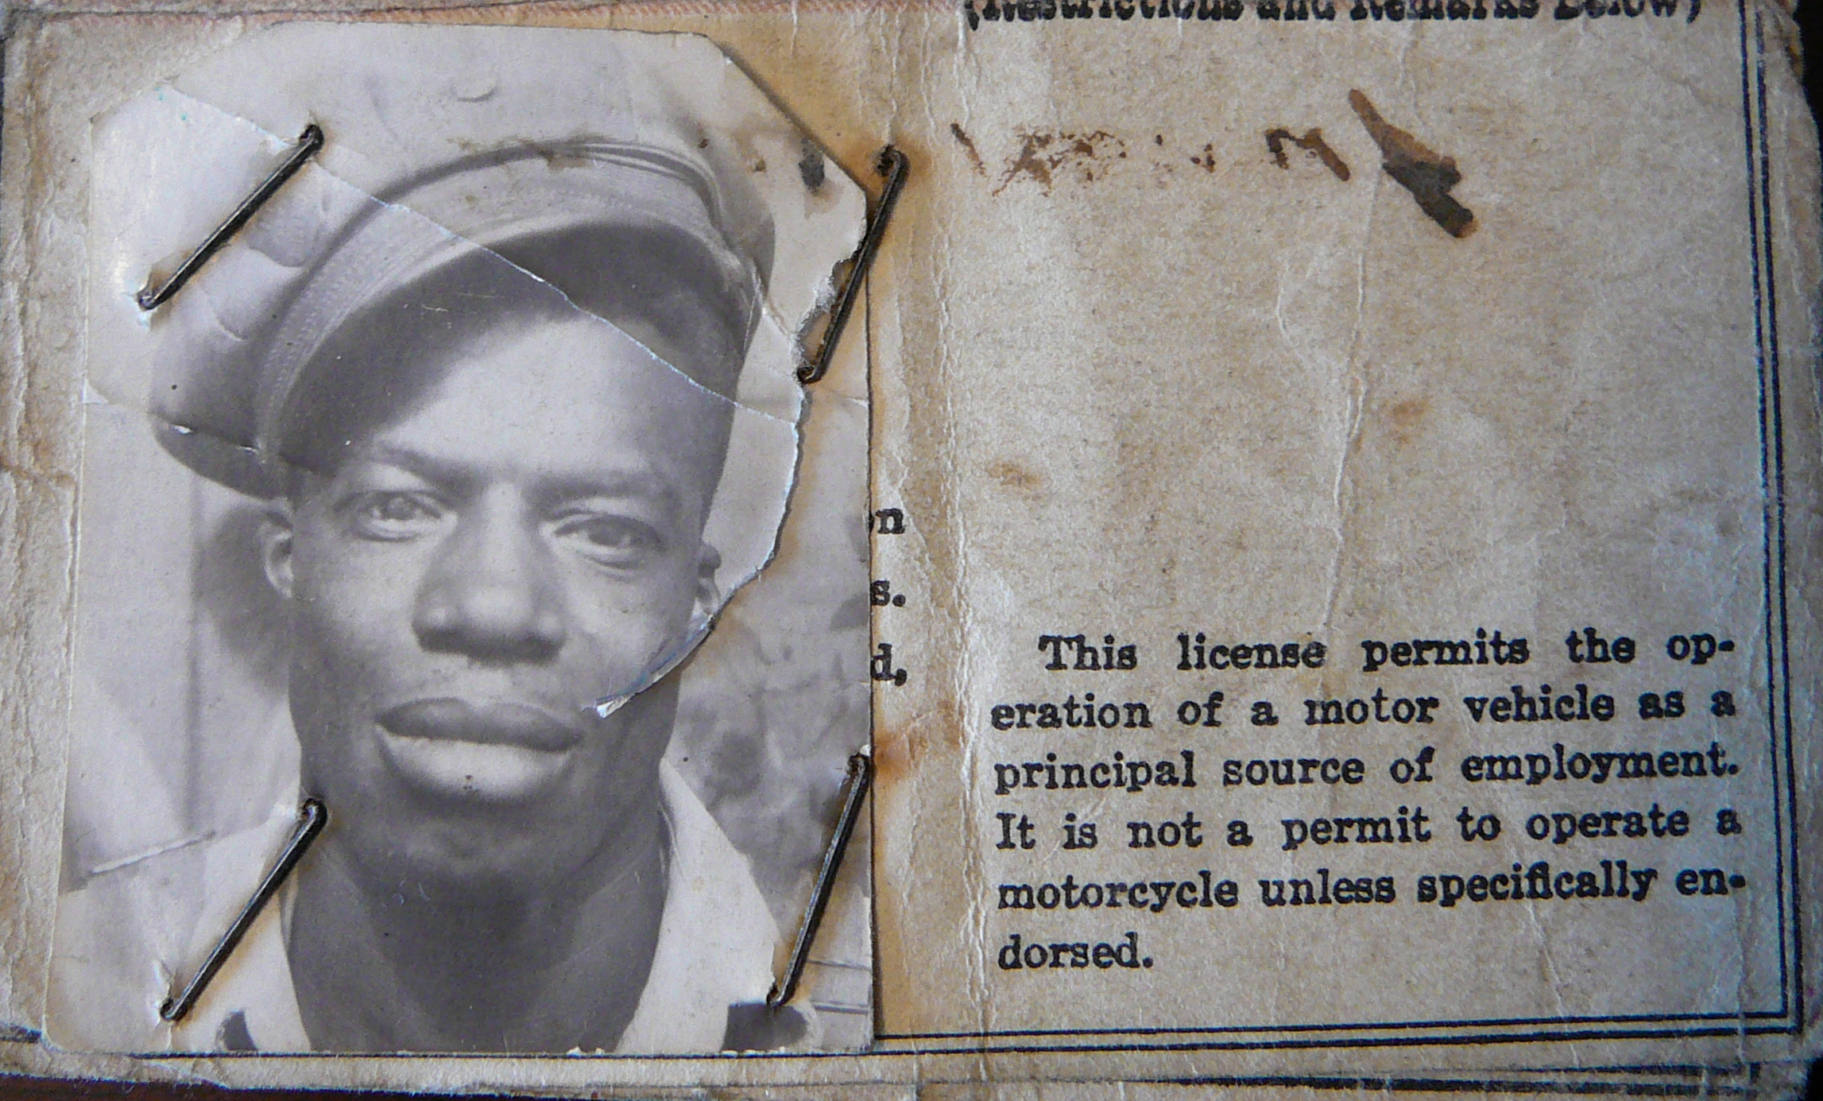
Goals:
By showing his collection and sharing stories about his family's experience growing up in the South during segregation, Tony hopes to educate the public about the racial indignities that African-Americans had to endure on a daily basis.

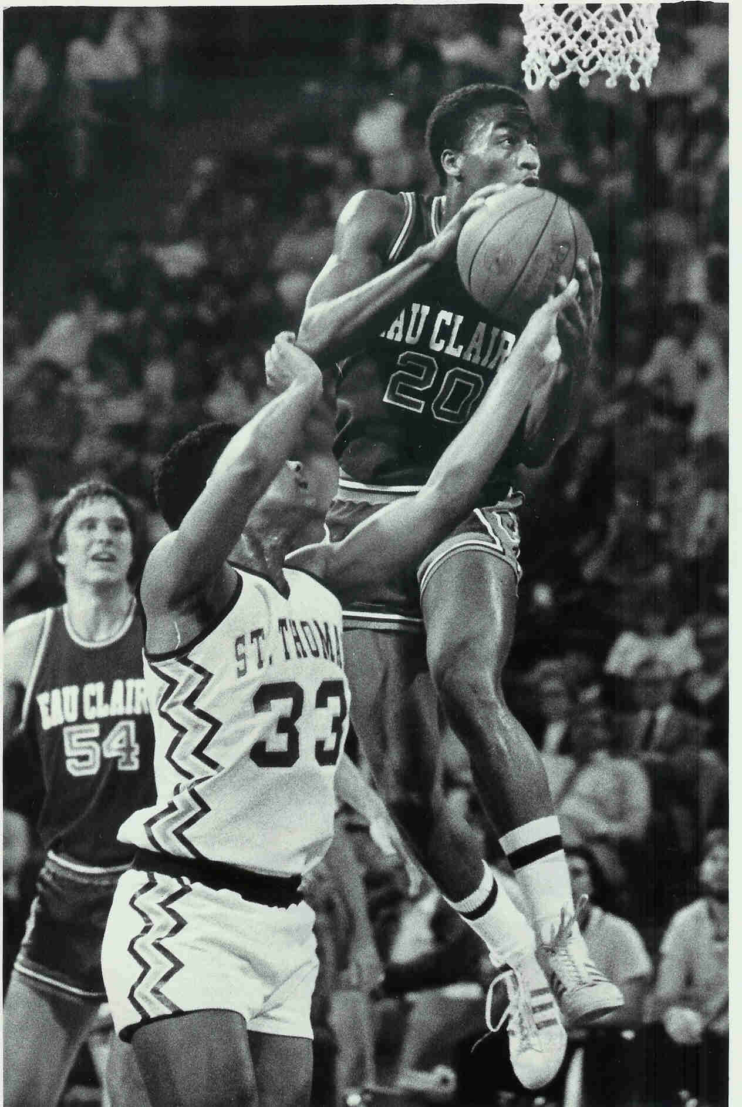

Instructor Bio:
Tony Carr has been collecting Black Memorabilia since 1986. He has more than 500 pieces in his collection. Tony grew up in Beloit, Wisconsin during the 1960’s and the era of integration. He excelled at basketball and is the All-Time leader scorer at the University of Wisconsin, Eau Claire. He trained for the 1980 Olympic basketball team and was drafted by the Milwaukee Bucks. He currently serves as the Chairman of the Stillwater Human Rights Commission and as a member of the Washington County Mental Health Advisory Council.

Outline:
I. Introduction to Instructor
- Growing up in the 60’s with integration
- Basketball Career
- Volunteer work

II. Growing up with segregation
- Mother’s experiences on bus
- Father’s experiences with curfews
- Grandfather’s experiences working as a truck driver
- Grandmother’s experiences working as a servant on a Plantation

III. Jim Crow Laws
- Examples (colored only sign, colored waiting room sign)

IV. Stereotypes
- Definition
- Examples (Blacks portrayed in postcards with watermelons and chickens)

V. Slang
- Everyday products using derogatory names (Niggerhair Tobacco, Nigger Head Stove Polish, Sheet music: “All Coons Look Alike to Me” - with audio clip.)

VI. Toys
- Examples (Coon Jiggers, Poor Pete, etc.)

VII. Alligator Bait
- Examples (Blacks portrayed as alligator bait in postcards, office products, etc.

VIII. Ku Klux Klan
- Examples (Klan statue, Klan knives, Klan tokens, etc.)

IX. Servants
- Examples (Black Boy Beer, Aunt Jemima, Mammy and Pappy salt and pepper shakers, etc.)

X. Home Grown Racism
- MN/WI based products (Mammy clock from Red Wing Pottery, Rastus from Cream of Wheat, Old Black Joe Axel Grease)

XI. Modern Day Racism
- Examples (Mexican stamp, Japanese commercial -with video clip, Spanish candy, Pokemon, Little Lulu cartoon purchased at Target- with video clip)

Resources:
Audio/Visual Equipment needed for PowerPoint Presentation: Video Projector and Speakers that will be hooked up to presenter’s laptop.

To book Tony Carr now visit
www.TonyCarr.org

